Java 2nd semester – Final Project

**Topic** – Web application for booking movie tickets

Roles – 1) Administrator (can edit and add records)

2) User (imitates customer – can book movie tickets and edit personal info)

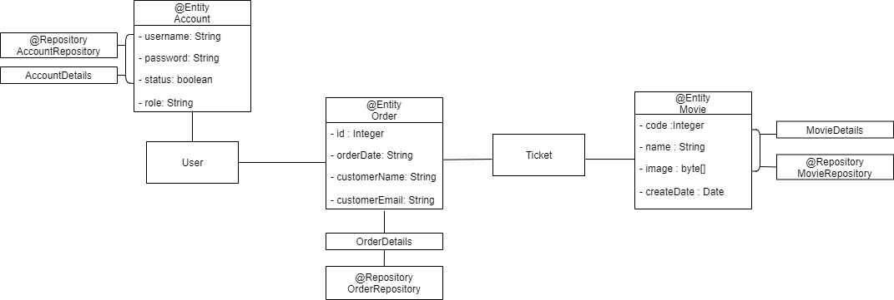

**Backend**: Java Spring Framework, REST API, Data JPA, Lombok, MySQL

**Frontend**: HTML, CSS, Bootstrap

1. At localhost:8080/ - Home page with app functionality

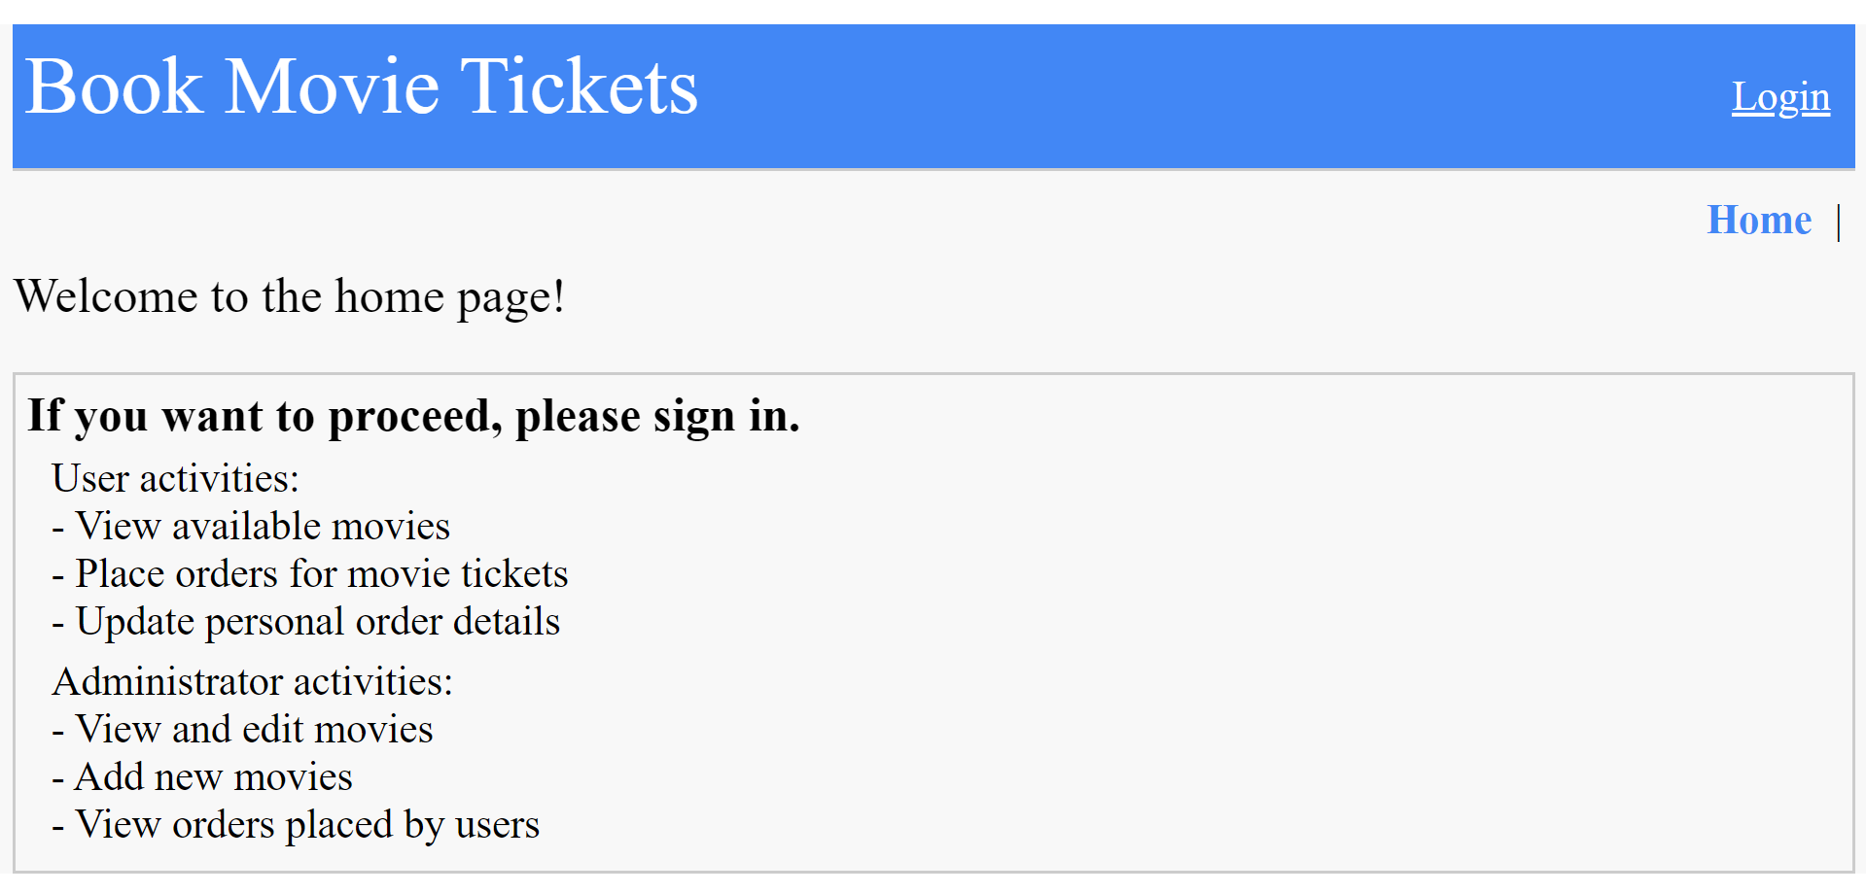

2. localhost:8080/login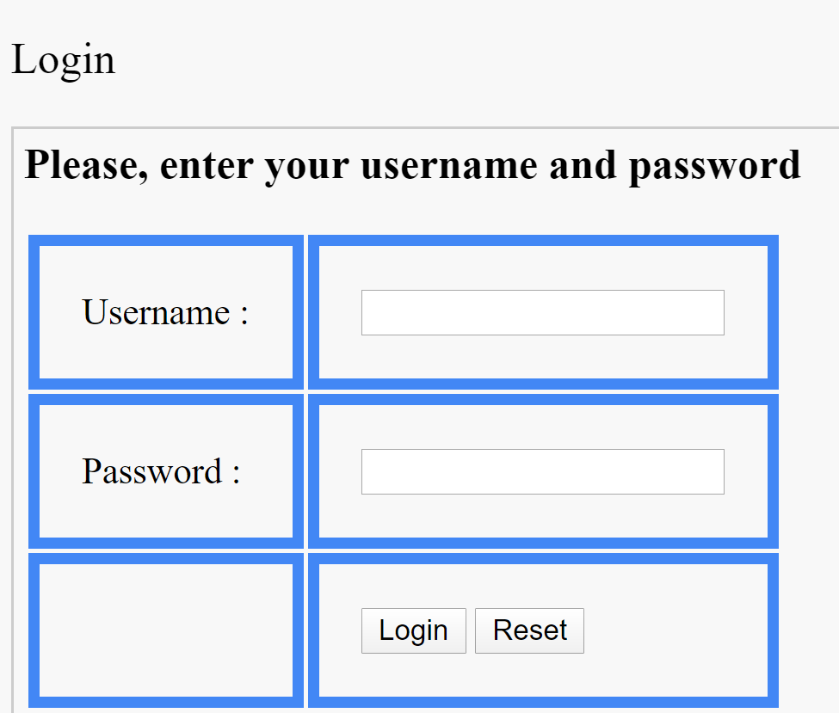

3. View as User - <http://localhost:8080/movieList>

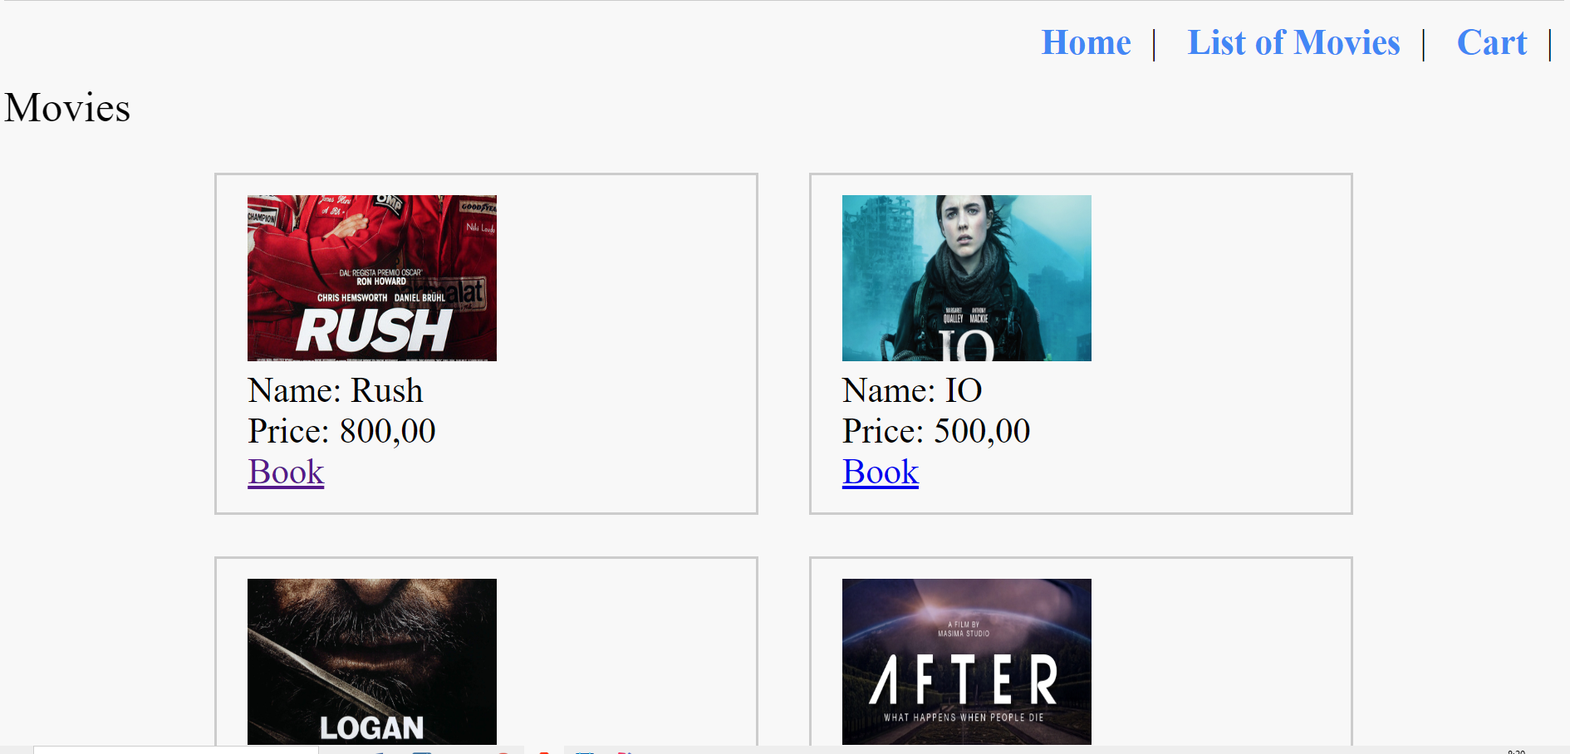

4. View as User - <http://localhost:8080/shoppingCart>

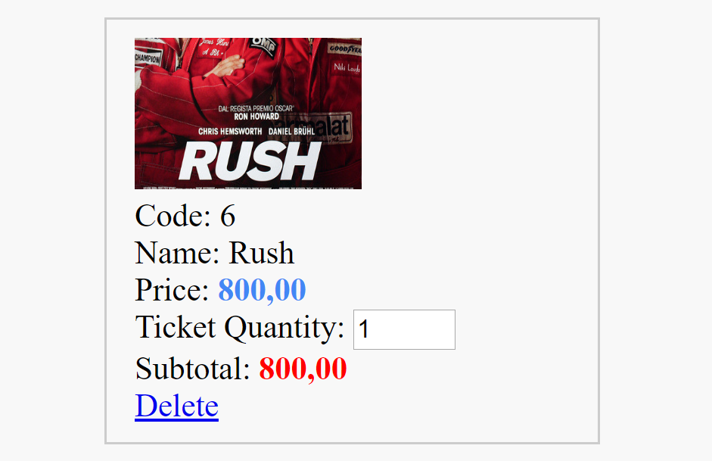

5. View as User - <http://localhost:8080/shoppingCartCustomer>

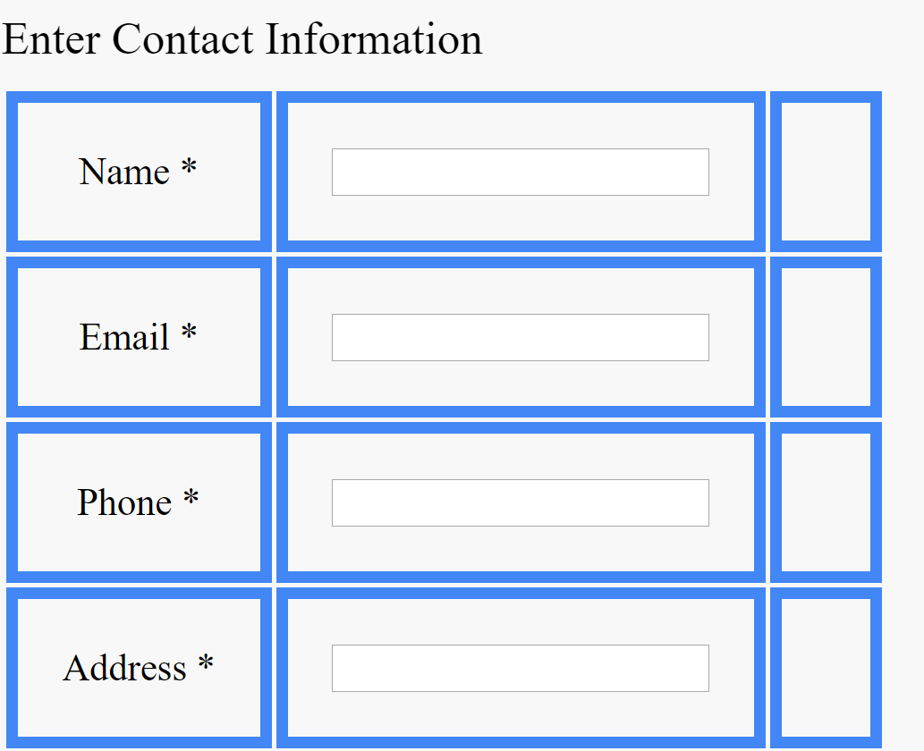

6. View as Admin - <http://localhost:8080/admin/orderList>

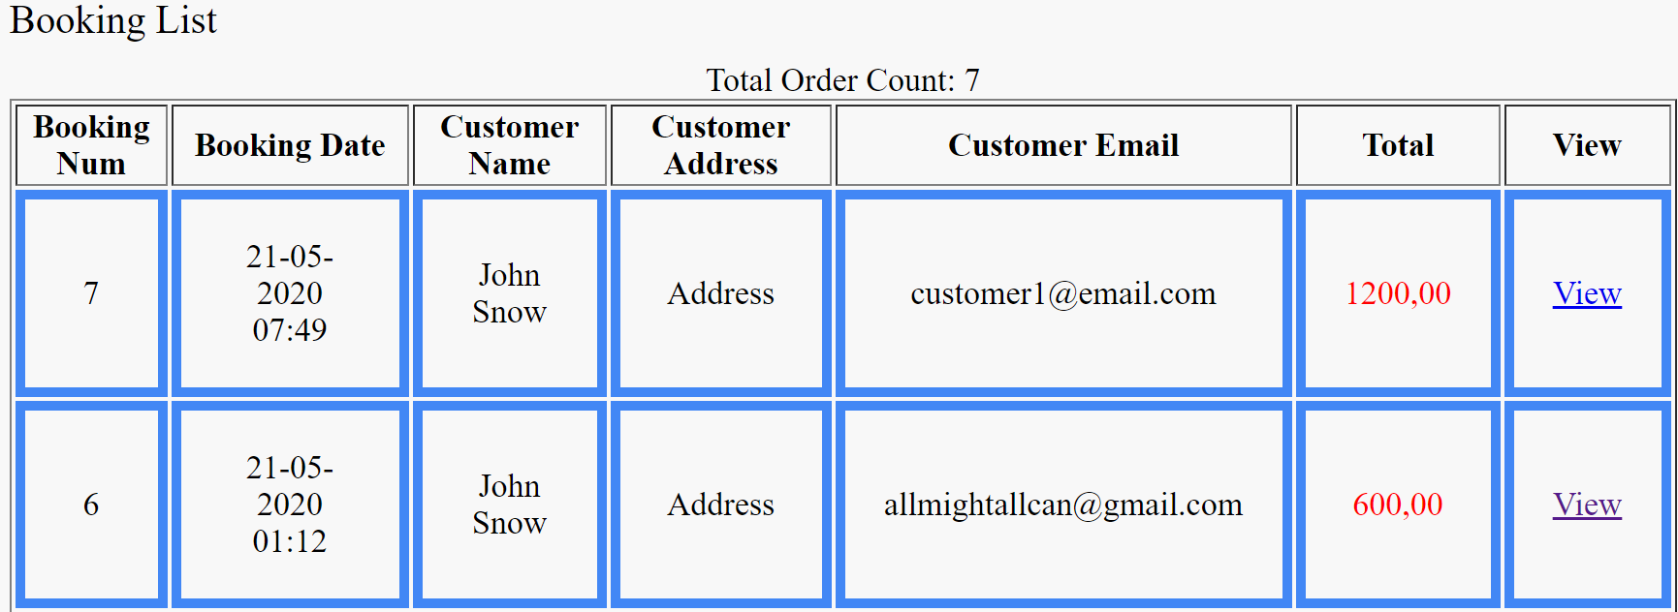

7. View as Admin - <http://localhost:8080/admin/movie>

